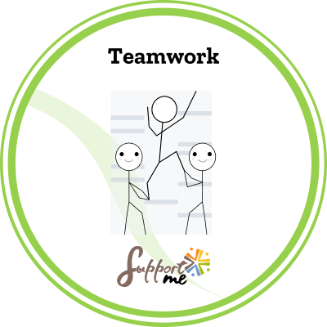

SUPPORT ME COMPETENCE: TEAMWORK

Issued by: ……………………………………………………
Earner: ………………………………………………………
Issued on: ………………………………………………………
DESCRIPTION
This badge was delivered by the pedagogical team of …………………………………………………. (name of the organisation or association).

CRITERIA
This badge of competence has been attributed to a beneficiary who has managed to clearly identify the competence by participating actively in the different Support Me pedagogical activities, which consisted of observation, reflection, role-playing, simulations, quizzes, escape games.
This combination of activities put the beneficiary in various situations where he / she had to act and reflect, which allowed him /her to identify the way that he / she personally related to the competence.
The activities, created by the project Support Me consortium funded by Erasmus +, have been conducted during the training session (name)………… for a period of ………………………… (hours or days).
Obtaining this badge indicates that the beneficiary is able to recognise the competence as:
- The ability to act as a team player respecting the individual’s specific backgrounds, competences and skills.
- The knowledge of verbal and non-verbal communication characteristics.
- The determination to contribute to a successful result when working with others.
- The awareness of the roles and capabilities of others.

