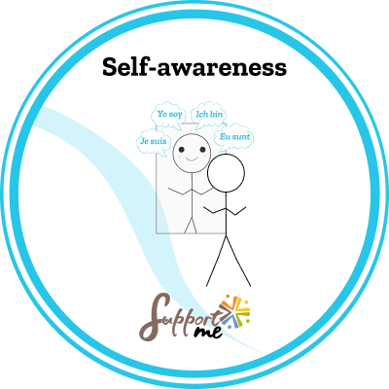

SUPPORT ME COMPETENCE: SELF-AWARENESS

Issued by: ……………………………………………………
Earner: ………………………………………………………
Issued on: ………………………………………………………
DESCRIPTION
This badge was delivered by the pedagogical team of …………………………………………………. (name of the organisation or association).

CRITERIA
This badge of competence has been attributed to a beneficiary who has managed to clearly identify the competence by participating actively in the different Support Me pedagogical activities, which consisted of observation, reflection, role-playing, simulations, quizzes, escape games.
This combination of activities put the beneficiary in various situations where he / she had to act and reflect, which allowed him /her to identify the way that he / she personally related to the competence.
The activities, created by the project Support Me consortium funded by Erasmus +, have been conducted during the training session (name)………… for a period of ………………………… (hours or days).
Obtaining this badge indicates that the beneficiary is able to recognise the competence as:
- The ability to understand one’s own identity, emotions, thoughts and values.
- The capacity to recognise one’s strengths and limitations.
- The ability to learn from one’s mistakes.
- The capacity to situate oneself in space and time.

