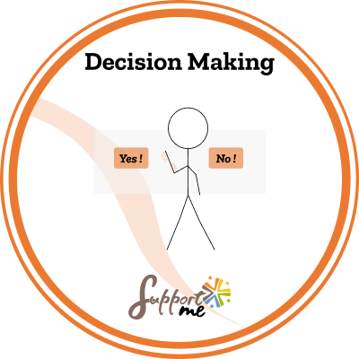

SUPPORT ME COMPETENCE: DECISION MAKING

Issued by: ……………………………………………………
Earner: ………………………………………………………
Issued on: ………………………………………………………
DESCRIPTION
This badge was delivered by the pedagogical team of …………………………………………………. (name of the organisation or association).

CRITERIA
This badge of competence has been attributed to a beneficiary who has managed to clearly identify the competence by participating actively in the different Support Me pedagogical activities, which consisted of observation, reflection, role-playing, simulations, quizzes, escape games.
This combination of activities put the beneficiary in various situations where he / she had to act and reflect, which allowed him /her to identify the way that he / she personally related to the competence.
The activities, created by the project Support Me consortium funded by Erasmus +, have been conducted during the training session (name)………… for a period of ………………………… (hours or days).
Obtaining this badge indicates that the beneficiary is able to recognise the competence as:
- The ability to choose the best option among several to achieve the desired objective.
- The ability to decide systematically, to commit and to be consistent.
- The consideration of values, motivations, influences and possible consequences.

